Online Resource 1 Text:

**Chronologies**

We used weak prior distributions of sediment accumulation and segment autocorrelation parameters to inform the age-depth models (Table 2). We constrained sediment accumulation rates to a gamma distribution with a mean of 10 (yr cm-1) and a shape (i.e., variance) parameter of 1, and assumed low, positive autocorrelation between discrete 0.5 cm core sections with a memory parameter of 0.1 and memory strength (variance) parameter of 10. We identified depths in each core where distinct changes in a combination of sediment type, stratigraphy, 14C dates, and/or charcoal concentration suggested abrupt down-core transitions to high or nearly instantaneous sediment accumulation rates. We modeled these points of transition using the hiatus functionality in Bacon with a mean length prior of 1 yr, although we do not interpret the transitions themselves as hiatuses.

Bacon uses an MCMC routine to generate thousands of potential distributions of sediment accumulation and sample autocorrelation, and fits age-depth models based on these parameters to dated samples. The estimated (interpolated) age of the core in continuous 0.25-cm segments is derived from the 50th percentile of the simulated ages, and 90% confidence intervals are derived from the 5th and 95th percentiles.

**Tree Demography Records**

Records from Duffy (2006) were collected in transects along the Nowitna River, each containing five “nodes.” Within each node, cross-sections from 3-6 of the largest trees were collected from five plots at the corners and center of a square with 100 m sides. Species were identified in the field, and where multiple species cohorts were present, samples were collected from each species. Cross-sections were sanded and annual rings were counted under a 10-40x stereomicroscope. Pith dates for each sample were estimated from annual ring counts, but were not cross-dated. Records collected in 2015 were taken from variable-radius plots adjacent to sampled lakes. Exact plot locations were randomly located within representative forest patches, and sized such that 20 or more adult trees were sampled. In total, 66 tree cores from three plots were collected, and species were identified in the field. Cores were sanded and annual rings were counted as with the cross sections, but all tree-core samples were visually and statistically cross dated with the computer program COFECHA (Grissino-Mayer 2001).

**Table S1.** Radiometric dates (14C and 210Pb) from all lakes. Asterisks (\*) after lab ID indicate dates not used in the age-depth model, mainly bulk 14C dates which were deemed systematically older than 14C dates based on macrofossils from nearby sediment depths.

|  |  |  |  |  |  |  |  |  |  |
| --- | --- | --- | --- | --- | --- | --- | --- | --- | --- |
| Site code | Top depth (cm) | Bottom depth (cm) | Material | 14C or 210Pb activity | 14C age or 210Pb activity st. dev. | Age  (cal yr BP) | Age 5th | Age 95th | Lab ID |
| BB15 | 0.00 | 0.50 | bulk sediment | 2.9753 | 0.1964 | -65.00 | -71.02 | -58.98 | Flett-75911 |
| BB15 | 0.50 | 1.00 | bulk sediment | 5.0651 | 0.2537 | -62.35 | -68.59 | -56.11 | Flett-75912 |
| BB15 | 1.00 | 1.50 | bulk sediment | 3.6862 | 0.1906 | -54.12 | -61.26 | -46.99 | Flett-75913 |
| BB15 | 1.50 | 2.00 | bulk sediment | 3.2887 | 0.2267 | -48.48 | -56.44 | -40.53 | Flett-75914 |
| BB15 | 2.00 | 2.50 | bulk sediment | 2.1192 | 0.1446 | -41.90 | -50.99 | -32.81 | Flett-75915 |
| BB15 | 2.00 | 2.50 | bulk sediment | 1.3187 | 0.0398 | - | - | - | Flett-75915\* |
| BB15 | 3.50 | 4.00 | bulk sediment | 2.2746 | 0.1511 | -26.94 | -39.87 | -14.01 | Flett-75918 |
| BB15 | 4.00 | 4.50 | bulk sediment | 1.4966 | 0.1808 | -19.05 | -34.85 | -3.25 | Flett-75919 |
| BB15 | 5.00 | 6.00 | bulk sediment | 1.8436 | 0.1397 | -11.87 | -30.56 | 6.82 | Flett-75921 |
| BB15 | 6.00 | 7.00 | bulk sediment | 1.7069 | 0.1509 | 8.91 | -20.78 | 38.61 | Flett-75922 |
| BB15 | 7.00 | 8.00 | bulk sediment | 1.3622 | 0.1632 | 58.28 | -36.14 | 152.71 | Flett-75923\* |
| BB15 | 8.00 | 9.00 | bulk sediment | 1.2045 | 0.1213 | - | - | - | Flett-75924\* |
| BB15 | 9.00 | 10.00 | bulk sediment | 1.1596 | 0.1126 | - | - | - | Flett-75925\* |
| BB15 | 9.00 | 10.00 | bulk sediment | 1.1130 | 0.0371 | - | - | - | Flett-75925\* |
| BB15 | 14.00 | 15.00 | bulk sediment | 1.5079 | 0.1234 | - | - | - | Flett-75930\* |
| BB15 | 31.75 | 32.00 | wood macrofossil | 0.9795 | 0.0036 | 178.00 | 5.00 | 281.00 | CAMS-175825 |
| BB15 | 39.50 | 39.75 | bulk sediment | 0.3299 | 0.0012 | 10036.00 | 9919.00 | 10176.00 | CAMS-176589\* |
| BB15 | 60.00 | 60.25 | wood macrofossil | 0.9817 | 0.0041 | 152.00 | 8.00 | 278.00 | CAMS-175826 |
| BB15 | 72.00 | 72.25 | wood macrofossil | 0.8782 | 0.0030 | 952.00 | 926.00 | 1042.00 | CAMS-175827 |
| BB15 | 91.25 | 91.50 | wood macrofossil | 0.9809 | 0.0035 | 173.00 | 7.00 | 278.00 | CAMS-175828 |
| DU15 | 0.00 | 0.75 | bulk sediment | 14.2798 | 0.5899 | -65.00 | -66.86 | -63.14 | Flett-75931 |
| DU15 | 1.25 | 1.75 | bulk sediment | 11.8882 | 0.4025 | -56.80 | -58.87 | -54.73 | Flett-75933 |
| DU15 | 2.50 | 3.25 | bulk sediment | 12.2693 | 0.4961 | -48.17 | -50.60 | -45.74 | Flett-75935 |
| DU15 | 2.50 | 3.25 | bulk sediment | 1.2595 | 0.0400 | - | - | - | Flett-75935\* |
| DU15 | 3.25 | 3.75 | bulk sediment | 10.8727 | 0.4196 | -42.95 | -45.65 | -40.25 | Flett-75936 |
| DU15 | 3.75 | 4.25 | bulk sediment | 5.9687 | 0.3280 | -37.77 | -40.79 | -34.74 | Flett-75937 |
| DU15 | 4.25 | 4.75 | bulk sediment | 4.8331 | 0.2980 | -33.66 | -36.97 | -30.35 | Flett-75938 |
| DU15 | 4.75 | 5.25 | bulk sediment | 4.3575 | 0.2734 | -30.07 | -33.66 | -26.49 | Flett-75939 |
| DU15 | 5.25 | 5.75 | bulk sediment | 3.1513 | 0.2199 | -25.41 | -29.39 | -21.43 | Flett-75940 |
| DU15 | 5.75 | 6.75 | bulk sediment | 2.8402 | 0.2034 | -21.96 | -26.26 | -17.67 | Flett-75941 |
| DU15 | 7.75 | 8.75 | bulk sediment | 2.9789 | 0.2531 | -5.86 | -11.47 | -0.26 | Flett-75943 |
| DU15 | 9.75 | 10.75 | bulk sediment | 2.7243 | 0.2509 | 18.72 | 10.80 | 26.64 | Flett-75945 |
| DU15 | 11.75 | 12.75 | bulk sediment | 2.1053 | 0.2042 | 54.83 | 39.59 | 70.07 | Flett-75947\* |
| DU15 | 13.75 | 15.00 | bulk sediment | 1.4379 | 0.2030 | - | - | - | Flett-75949\* |
| DU15 | 13.75 | 15.00 | bulk sediment | 1.3232 | 0.0400 | - | - | - | Flett-75949\* |
| DU15 | 50.00 | 50.25 | wood macrofossil | 0.0935 | 0.0006 | 22916.00 | 22768.00 | 23034.00 | CAMS-175829 |
| DU15 | 55.75 | 56.00 | bulk sediment | 0.2805 | 0.0011 | 11786.00 | 11922.00 | 12038.00 | CAMS-176590\* |
| DU15 | 73.75 | 74.00 | wood macrofossil | 0.0835 | 0.0006 | 24006.00 | 23882.00 | 24128.03 | CAMS-175830 |
| DU15 | 106.50 | 106.75 | wood macrofossil | 0.0771 | 0.0006 | 24783.00 | 24551.00 | 25031.00 | CAMS-175831 |
| DU15 | 111.00 | 111.25 | wood macrofossil | 0.0784 | 0.0006 | 24546.00 | 24396.00 | 24856.00 | CAMS-175832 |
| MA15 | 0.00 | 0.50 | bulk sediment | 19.2996 | 0.5822 | -65.00 | -67.11 | -62.89 | Flett-77259 |
| MA15 | 0.50 | 1.00 | bulk sediment | 19.4721 | 0.6275 | -55.21 | -57.58 | -52.85 | Flett-77260 |
| MA15 | 1.00 | 1.50 | bulk sediment | 14.0752 | 0.4909 | -41.48 | -44.35 | -38.61 | Flett-77261 |
| MA15 | 1.50 | 2.00 | bulk sediment | 9.8065 | 0.3865 | -25.48 | -29.29 | -21.67 | Flett-77262 |
| MA15 | 2.00 | 2.50 | bulk sediment | 6.5494 | 0.3677 | -9.18 | -14.55 | -3.81 | Flett-77263 |
| MA15 | 2.50 | 3.00 | bulk sediment | 4.7233 | 0.2818 | 7.99 | 0.30 | 15.69 | Flett-77264 |
| MA15 | 3.00 | 3.50 | bulk sediment | 2.7286 | 0.1968 | 26.18 | 14.61 | 37.76 | Flett-77265 |
| MA15 | 3.50 | 4.00 | bulk sediment | 2.4020 | 0.1792 | 38.23 | 23.81 | 52.65 | Flett-77266 |
| MA15 | 4.00 | 4.50 | bulk sediment | 2.9280 | 0.2283 | 51.21 | 33.21 | 69.21 | Flett-77267 |
| MA15 | 4.50 | 5.00 | bulk sediment | 1.7636 | 0.1658 | 98.21 | 45.58 | 150.85 | Flett-77268\* |
| MA15 | 5.00 | 6.00 | bulk sediment | 1.2095 | 0.1451 | - | - | - | Flett-77269\* |
| MA15 | 5.00 | 6.00 | bulk sediment | 0.9711 | 0.0337 | - | - | - | Flett-77269\* |
| MA15 | 9.00 | 10.00 | bulk sediment | 2.0659 | 0.1934 | - | - | - | Flett-77273\* |
| MA15 | 14.00 | 15.00 | bulk sediment | 1.1827 | 0.1582 | - | - | - | Flett-77278\* |
| MA15 | 14.00 | 15.00 | bulk sediment | 1.5298 | 0.0412 | - | - | - | Flett-77278\* |
| MA15 | 15.25 | 15.50 | wood macrofossil | 0.9627 | 0.0031 | 387.00 | 303.00 | 458.00 | CAMS-176005 |
| MA15 | 15.25 | 15.50 | bulk sediment | 0.4877 | 0.0018 | 6574.00 | 6497.00 | 6646.00 | CAMS-176591\* |
| MA15 | 21.25 | 22.00 | wood macrofossil | 0.9833 | 0.0050 | 136.00 | 10.00 | 276.00 | CAMS-176006 |
| MA15 | 66.50 | 66.75 | wood macrofossil | 0.9595 | 0.0035 | 387.00 | 311.00 | 476.00 | CAMS-176007 |
| NW15 | 0.00 | 0.50 | bulk sediment | 14.9582 | 0.8668 | -65.00 | -62.64 | -67.36 | Flett-77219 |
| NW15 | 1.00 | 1.50 | bulk sediment | 15.9483 | 0.7607 | -61.77 | -59.30 | -64.25 | Flett-77221 |
| NW15 | 2.00 | 2.50 | bulk sediment | 14.0353 | 0.7528 | -57.96 | -55.32 | -60.60 | Flett-77223 |
| NW15 | 3.00 | 3.50 | bulk sediment | 1.6614 | 0.1745 | - | - | - | Flett-77225\* |
| NW15 | 3.50 | 4.00 | bulk sediment | 12.4801 | 0.6748 | -52.29 | -49.35 | -55.22 | Flett-77226 |
| NW15 | 6.00 | 7.00 | bulk sediment | 9.2710 | 0.5594 | -42.05 | -38.41 | -45.69 | Flett-77230 |
| NW15 | 10.00 | 11.00 | bulk sediment | 8.0172 | 0.4285 | -21.24 | -16.17 | -26.30 | Flett-77234 |
| NW15 | 13.00 | 14.00 | bulk sediment | 1.3217 | 0.0687 | - | - | - | Flett-77237\* |
| NW15 | 14.00 | 15.00 | bulk sediment | 6.6813 | 0.4205 | 19.09 | 32.60 | 5.58 | Flett-77238 |
| NW15 | 19.00 | 20.00 | bulk sediment | 4.5611 | 0.2171 | 167.51 | 176.45 | 158.56 | Flett-78515\* |
| NW15 | 23.50 | 24.50 | bulk sediment | 6.0981 | 0.3346 | - | - | - | Flett-78517\* |
| NW15 | 25.50 | 26.50 | bulk sediment | 0.7275 | 0.0030 | 2705.00 | 2507.00 | 2747.00 | CAMS-176228\* |
| NW15 | 46.50 | 47.25 | bulk sediment | 0.5679 | 0.0165 | 5192.00 | 4571.00 | 5759.00 | CAMS-176229\* |
| NW15 | 72.75 | 74.25 | concentrated charcoal | 0.8571 | 0.0031 | 1195.00 | 1079.00 | 1263.00 | CAMS-176230 |
| SH15 | 0.00 | 0.50 | bulk sediment | 5.5858 | 0.3015 | -65.00 | -68.18 | -61.82 | Flett-77239 |
| SH15 | 0.50 | 1.00 | bulk sediment | 8.6176 | 0.3667 | -59.72 | -63.09 | -56.35 | Flett-77240 |
| SH15 | 1.00 | 1.50 | bulk sediment | 9.2358 | 0.3783 | -49.31 | -53.27 | -45.35 | Flett-77241 |
| SH15 | 1.50 | 2.00 | bulk sediment | 6.1228 | 0.2767 | -32.09 | -37.69 | -26.48 | Flett-77242 |
| SH15 | 2.00 | 2.50 | bulk sediment | 3.7203 | 0.2324 | -13.72 | -22.65 | -4.79 | Flett-77243 |
| SH15 | 2.50 | 3.00 | bulk sediment | 2.7599 | 0.1888 | 1.49 | -12.03 | 15.02 | Flett-77244 |
| SH15 | 3.00 | 3.50 | bulk sediment | 2.2555 | 0.1800 | 14.27 | -5.24 | 33.77 | Flett-77245 |
| SH15 | 3.50 | 4.00 | bulk sediment | 1.7370 | 0.1415 | 24.68 | -1.71 | 51.07 | Flett-77246 |
| SH15 | 3.50 | 4.00 | bulk sediment | 1.4222 | 0.0374 | - | - | - | Flett-77246\* |
| SH15 | 6.00 | 7.00 | bulk sediment | 1.5947 | 0.1372 | 52.72 | -6.76 | 112.20 | Flett-77250\* |
| SH15 | 10.00 | 11.00 | bulk sediment | 1.2459 | 0.1151 | - | - | - | Flett-77254\* |
| SH15 | 10.00 | 11.00 | bulk sediment | 1.4033 | 0.0383 | - | - | - | Flett-77254\* |
| SH15 | 14.00 | 15.00 | bulk sediment | 1.4609 | 0.1581 | - | - | - | Flett-77258 |
| SH15 | 15.75 | 16.00 | bulk sediment | 0.7310 | 0.0026 | 2588.00 | 2496.00 | 2732.00 | CAMS-176592\* |
| SH15 | 25.75 | 26.00 | concentrated charcoal | 0.9302 | 0.0034 | 603.00 | 537.00 | 644.00 | CAMS-176008 |
| SH15 | 26.75 | 27.00 | wood macrofossil | 0.9389 | 0.0029 | 527.00 | 508.00 | 614.00 | CAMS-176009 |
| SH15 | 33.00 | 33.25 | wood macrofossil | 0.9478 | 0.0034 | 498.00 | 342.00 | 521.00 | CAMS-176010 |
| SH15 | 33.75 | 34.00 | concentrated charcoal | 0.9378 | 0.0034 | 531.00 | 511.00 | 619.00 | CAMS-176011 |
| SH15 | 40.00 | 40.25 | concentrated charcoal | 0.9324 | 0.0052 | 592.00 | 522.00 | 648.00 | CAMS-176012 |
| SH15 | 42.00 | 42.25 | wood macrofossil | 0.9476 | 0.0033 | 498.00 | 344.00 | 520.00 | CAMS-176013 |
| TL15 | 0.00 | 1.00 | bulk sediment | 6.9937 | 0.3242 | -65.00 | -67.65 | -62.35 | Flett-75970 |
| TL15 | 1.00 | 2.00 | bulk sediment | 11.6154 | 0.3707 | -54.52 | -57.40 | -51.64 | Flett-75971 |
| TL15 | 2.00 | 2.50 | bulk sediment | 7.5257 | 0.2707 | -20.78 | -25.61 | -15.95 | Flett-75972 |
| TL15 | 2.50 | 3.00 | bulk sediment | 2.4663 | 0.1883 | 9.16 | -1.36 | 19.68 | Flett-75973 |
| TL15 | 3.00 | 3.50 | bulk sediment | 1.5936 | 0.1536 | 35.20 | 15.14 | 55.26 | Flett-75974 |
| TL15 | 3.50 | 4.00 | bulk sediment | 1.0888 | 0.1206 | 65.85 | 23.11 | 108.58 | Flett-75975 |
| TL15 | 4.00 | 4.50 | bulk sediment | 1.0064 | 0.1108 | 94.36 | 20.69 | 168.02 | Flett-75976 |
| TL15 | 4.50 | 5.00 | bulk sediment | 0.6937 | 0.0923 | - | - | - | Flett-75977\* |
| TL15 | 7.00 | 8.00 | bulk sediment | 0.7313 | 0.0930 | - | - | - | Flett-75980\* |
| TL15 | 10.00 | 11.00 | bulk sediment | 1.0085 | 0.1074 | - | - | - | Flett-75983\* |
| TL15 | 14.00 | 15.00 | bulk sediment | 0.9544 | 0.0972 | - | - | - | Flett-75987\* |
| TL15 | 29.25 | 29.50 | bulk sediment | 0.4823 | 0.0022 | 6646.00 | 6551.00 | 6720.00 | CAMS-176593\* |
| TL15 | 68.25 | 68.50 | wood macrofossil | 0.9552 | 0.0034 | 437.00 | 322.00 | 496.00 | CAMS-175833 |
| UR15 | 0.00 | 0.50 | bulk sediment | 10.3464 | 0.4384 | -65.00 | -73.19 | -56.81 | Flett-77199 |
| UR15 | 0.50 | 1.00 | bulk sediment | 6.3729 | 0.3080 | -53.61 | -63.57 | -43.64 | Flett-77200 |
| UR15 | 1.00 | 1.50 | bulk sediment | 4.9635 | 0.2634 | -45.88 | -57.61 | -34.15 | Flett-77201 |
| UR15 | 1.50 | 2.00 | bulk sediment | 6.5949 | 0.3382 | -38.98 | -52.80 | -25.17 | Flett-77202 |
| UR15 | 2.00 | 2.50 | bulk sediment | 6.2717 | 0.3043 | -25.32 | -45.15 | -5.48 | Flett-77203 |
| UR15 | 2.50 | 3.00 | bulk sediment | 2.8435 | 0.2099 | -3.18 | -41.03 | 34.67 | Flett-77204 |
| UR15 | 2.50 | 3.00 | bulk sediment | 1.3108 | 0.0386 | - | - | - | Flett-77204\* |
| UR15 | 3.00 | 3.50 | bulk sediment | 2.6720 | 0.2032 | 8.58 | -45.31 | 62.47 | Flett-77205 |
| UR15 | 3.50 | 4.00 | bulk sediment | 1.3147 | 0.1553 | 30.31 | -74.20 | 134.83 | Flett-77206 |
| UR15 | 4.00 | 4.50 | bulk sediment | 1.2320 | 0.1202 | 34.23 | -83.13 | 151.59 | Flett-77207 |
| UR15 | 6.00 | 7.00 | bulk sediment | 1.3342 | 0.1531 | 51.54 | -146.32 | 249.40 | Flett-77210 |
| UR15 | 10.00 | 11.00 | bulk sediment | 1.0823 | 0.1290 | 149.46 | -2739.93 | 3038.86 | Flett-77214\* |
| UR15 | 12.50 | 12.75 | wood macrofossil | 0.9185 | 0.0035 | 651.00 | 565.00 | 680.00 | CAMS-176598 |
| UR15 | 14.00 | 15.00 | bulk sediment | 0.9530 | 0.1195 | - | - | - | Flett-77218\* |
| UR15 | 14.00 | 15.00 | bulk sediment | 0.8339 | 0.0352 | - | - | - | Flett-77218\* |
| UR15 | 29.00 | 29.25 | bulk sediment | 0.7070 | 0.0030 | 2883.00 | 2795.00 | 2964.00 | CAMS-176594\* |
| UR15 | 52.00 | 52.25 | bulk sediment | 0.4841 | 0.0017 | 6646.00 | 6551.00 | 6720.00 | CAMS-176595\* |

Complete age-depth models corresponding core images for records presented in Chapter 1.

**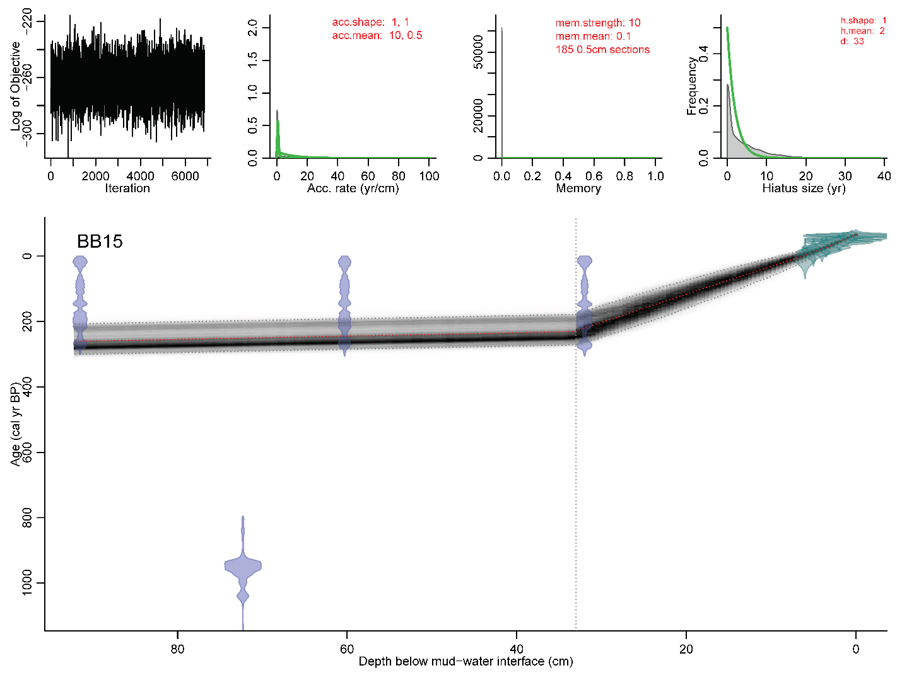**

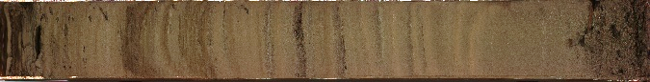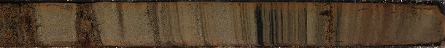

**Figure 1.** Buster Brown Lake (BB15) chronology and core. Hiatus depth is based on radiocarbon ages and distinct change laminated to unlaminated sediment at 32 cm core depth.

L:\1_projectsData\AK_PalEON\Analysis\Lakes\DU15\Photos\DU15_1A.jpg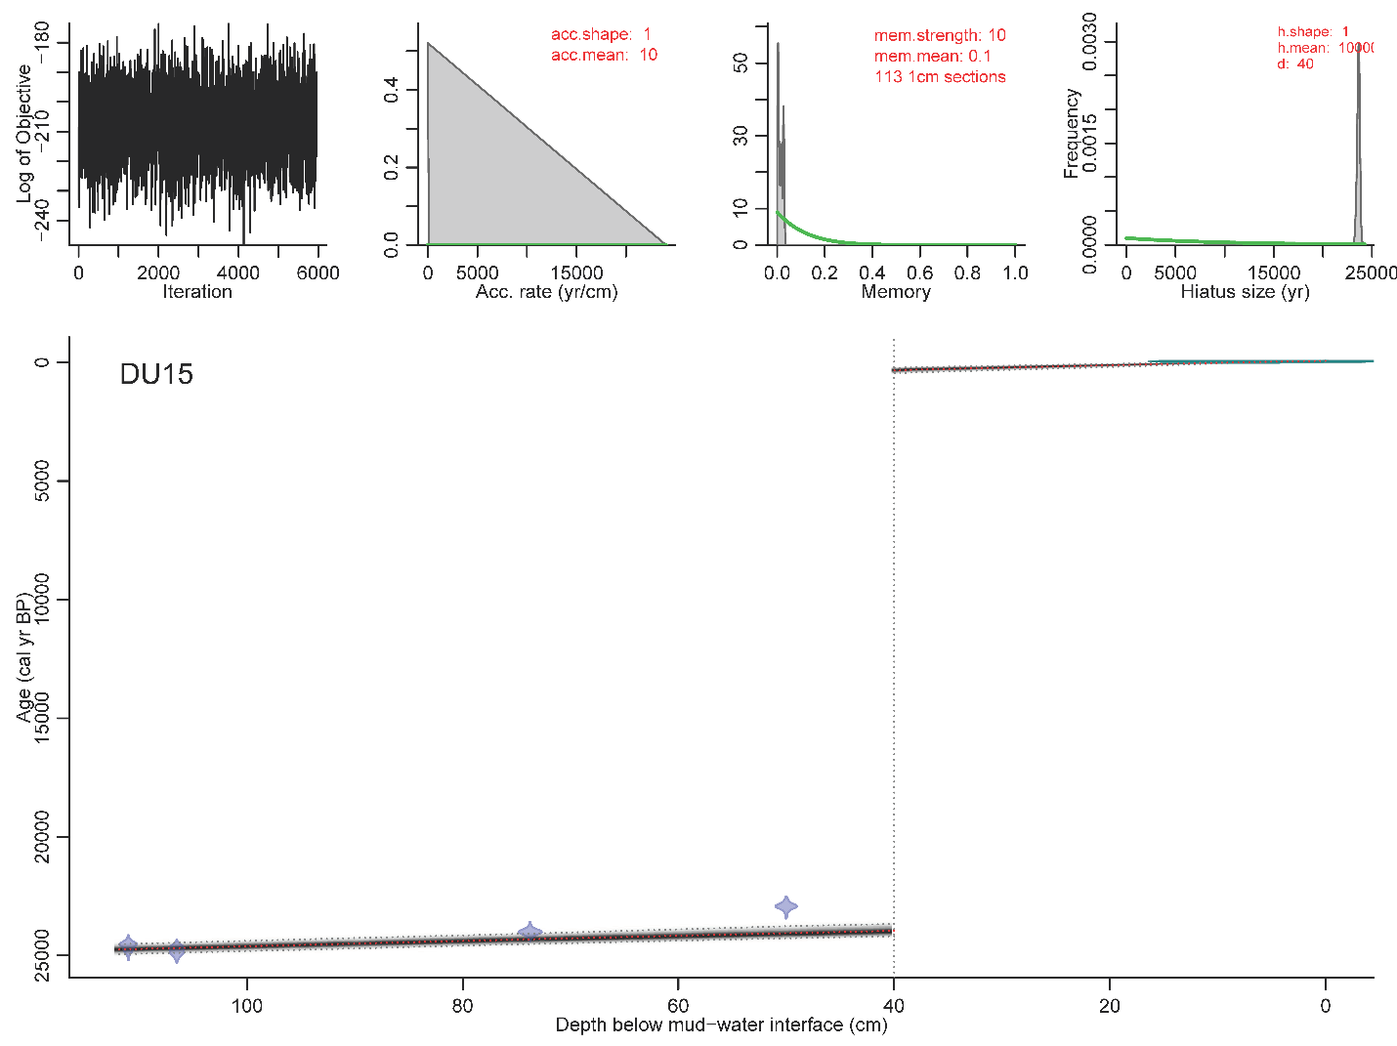

**Figure 2.** Duffy Lake (DU15) chronology and core. Hiatus depth is based on change from laminated to unlaminated sediment at 40 cm core depth.

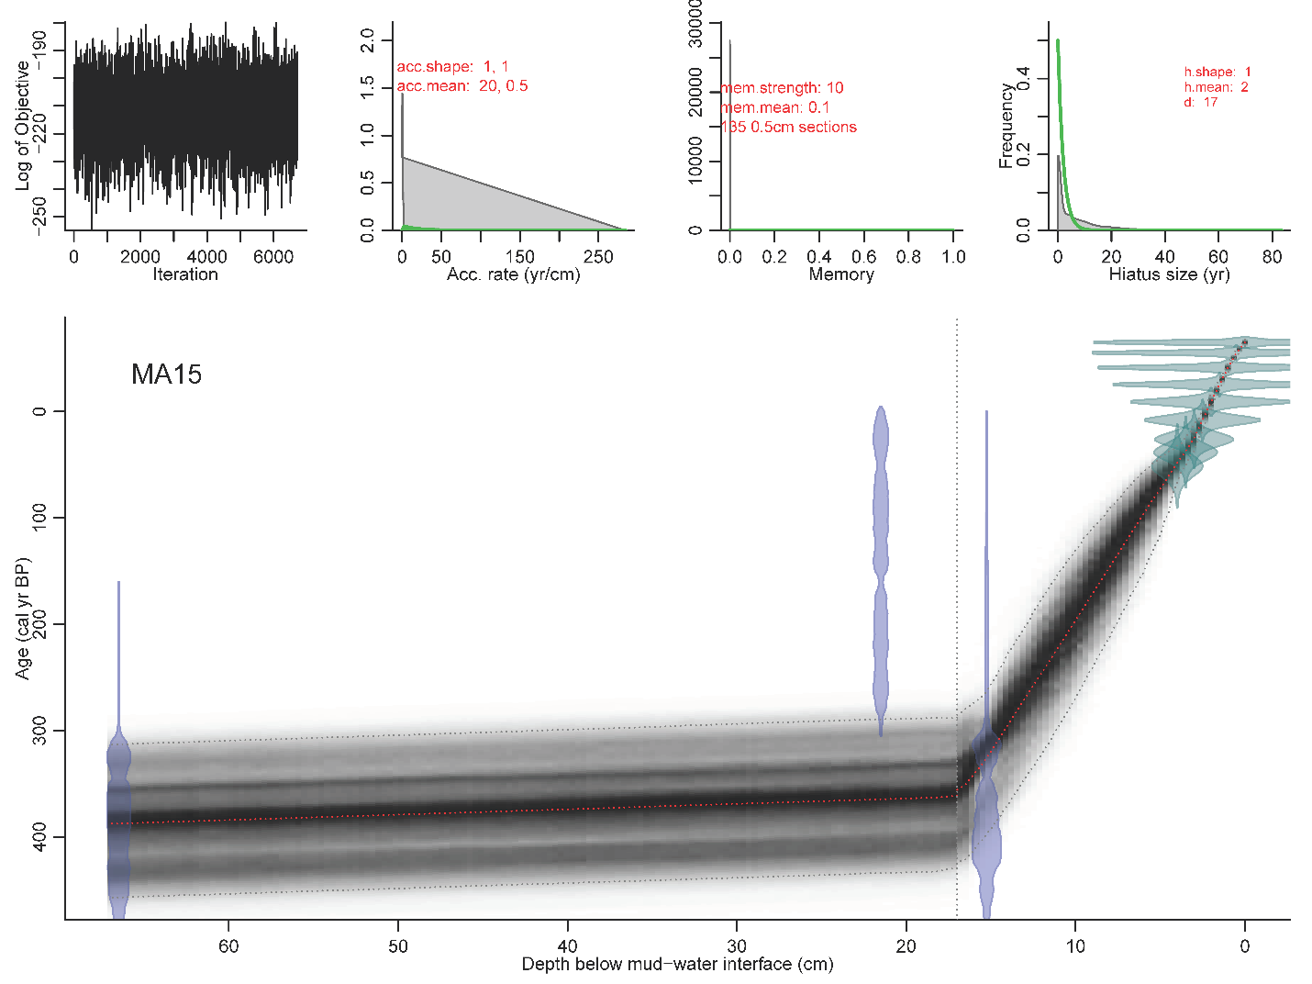

**Figure 3.** Macchiato Lake (MA15) chronology and core. Hiatus depth is based on radiocarbon ages and distinct change from laminated to unlaminated sediment at 16 cm core depth.

**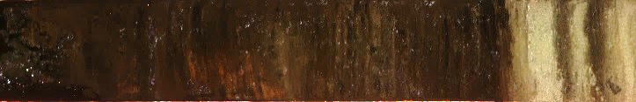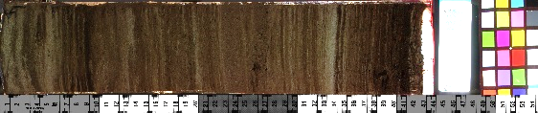**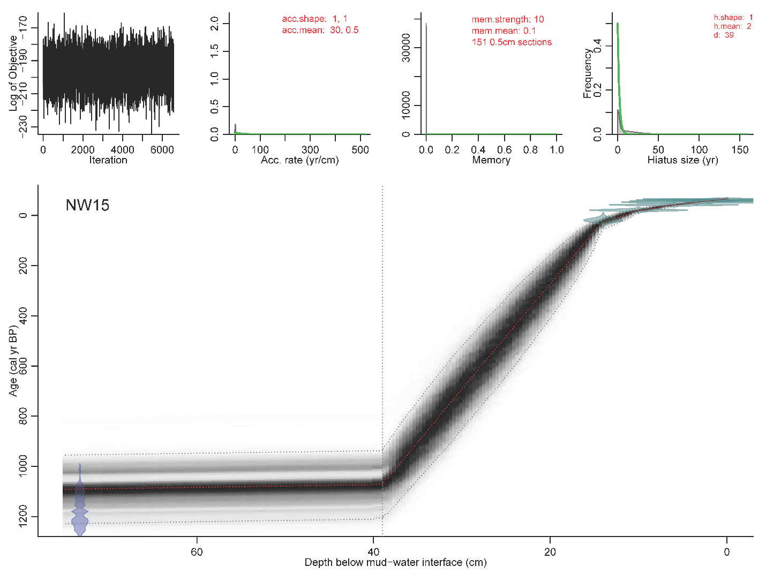

**Figure 4.** Nodwell Lake (NW15) chronology with hiatus at 39 cm based on change in charcoal concentration. This is the chronology presented in Chapter 1.

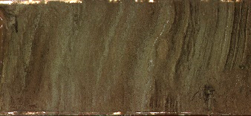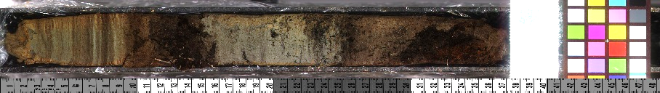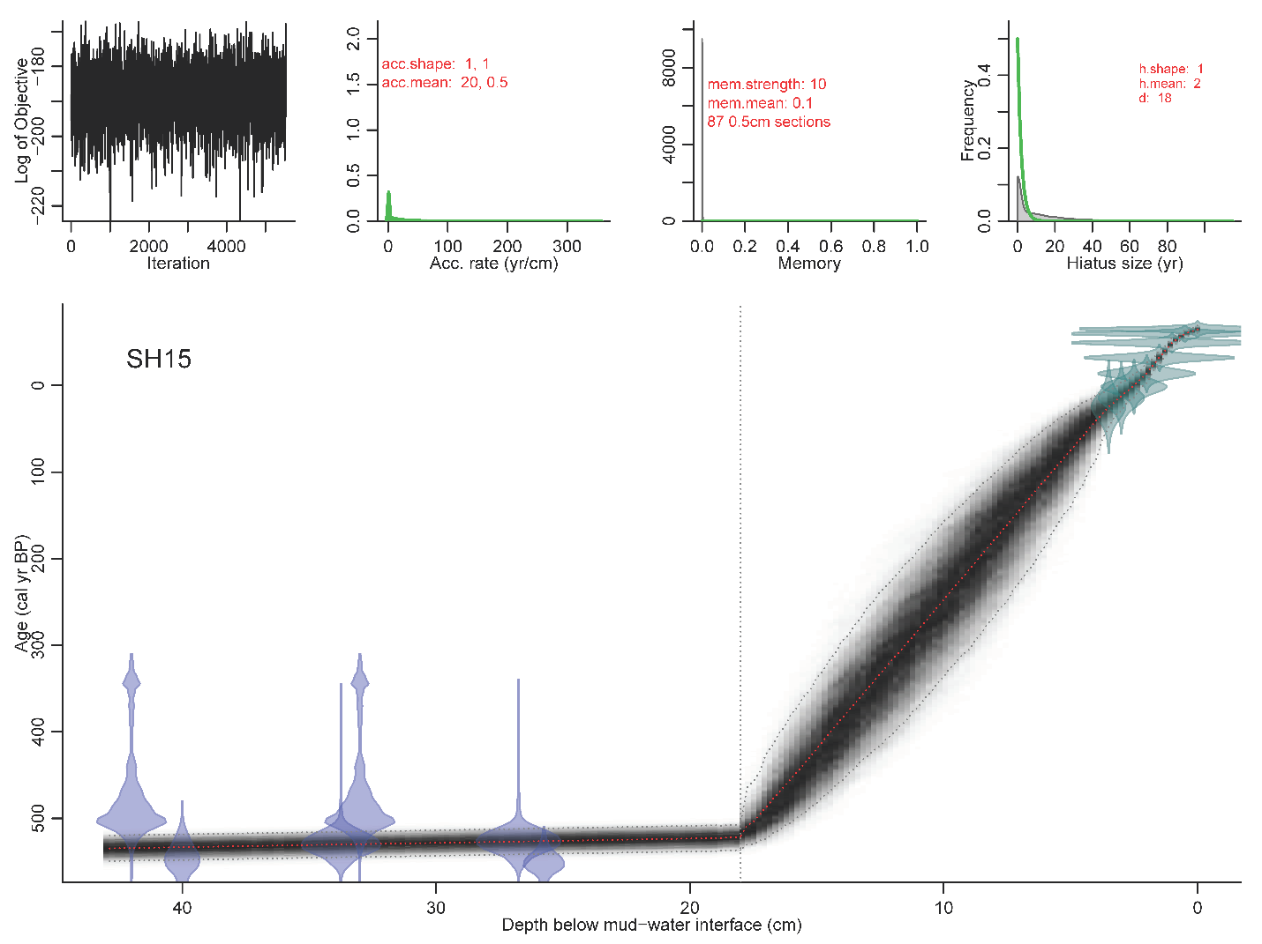

**Figure 5.** Shapiro Lake (SH15) chronology and core. Hiatus is based on distinct change from laminated to unlamented sediment at 18 cm core depth.

****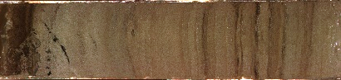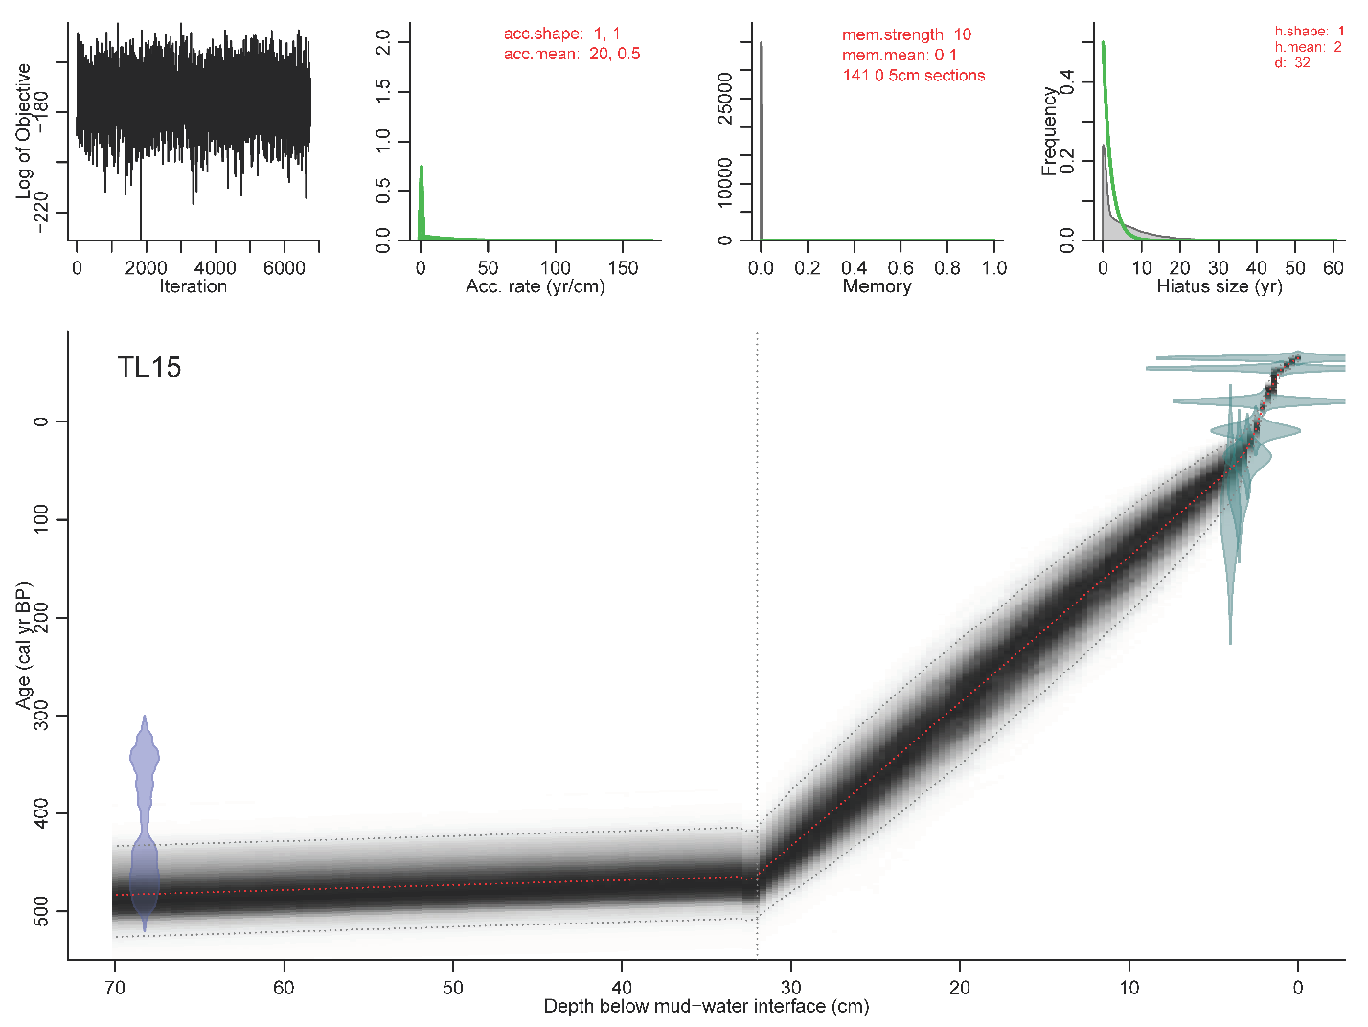

**Figure 6.** Three Lodge Lake (TL15) chronology and core. Hiatus is based on distinct change from laminated to unlamented sediment at 32 cm core depth.

**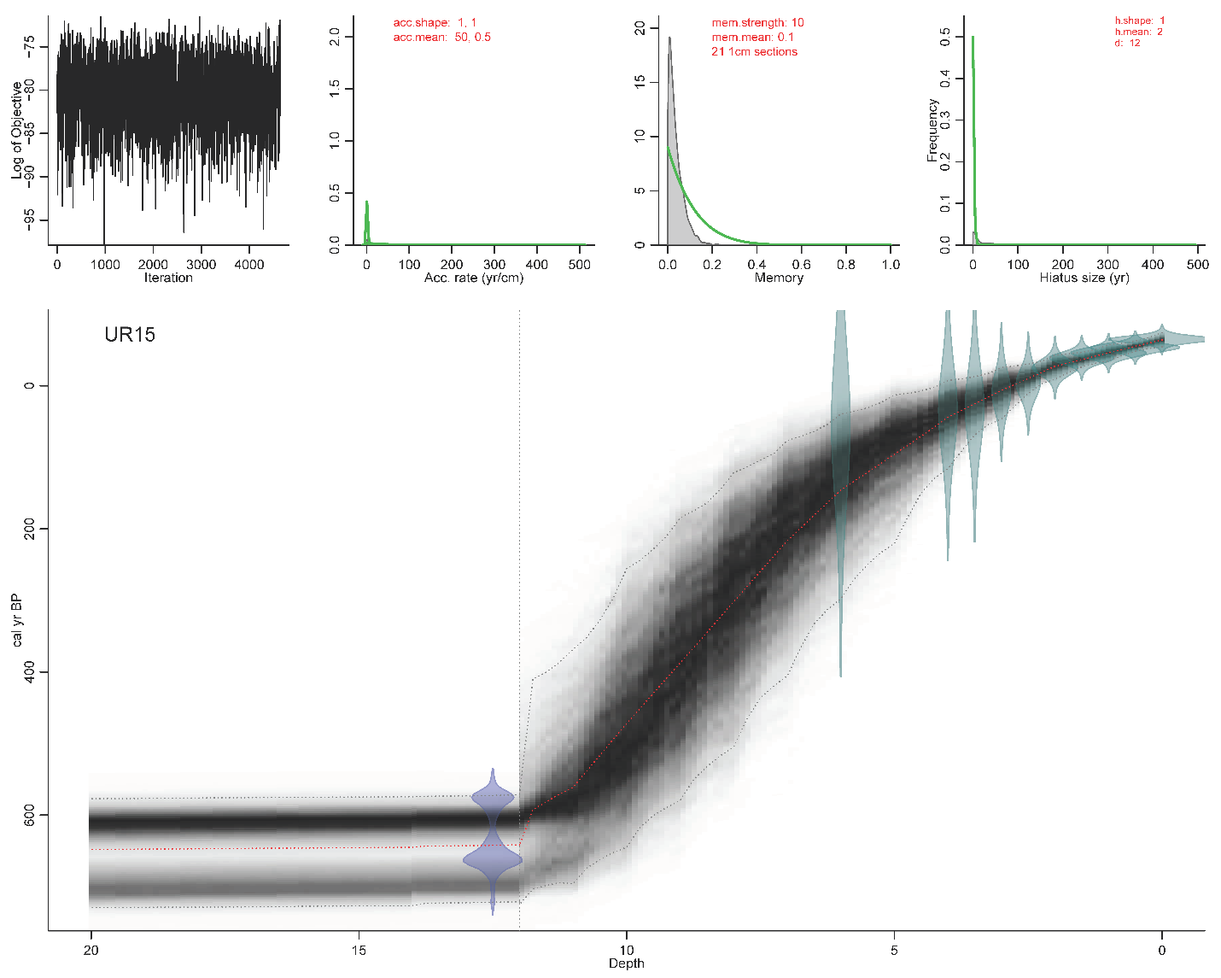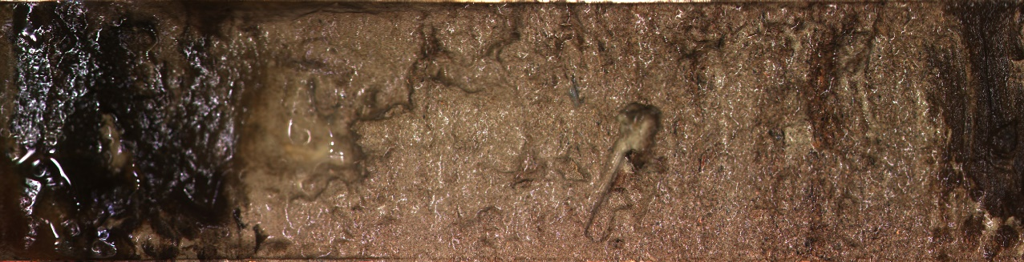**

**Figure 7.** Ursa Lake (UR15) chronology and core. Hiatus is based on change in charcoal concentration at 12 cm core depth.